Lecture 11: Markets and consumer demand
Markets and consumer demand
- Access
- Preferences
- Income and consumption
- Elasticities
- Marginal propensities to consume
- Terms of trade
- Commodities to examine

Readings
- Timmer, C. P., W.D. Falcon, and S.R. Pearson (1983) Food Policy Analysis. Baltimore: Johns Hopkins University Press. Pp. 35-60 “Food Consumption Analysis.” http://www.stanford.edu/group/FRI/indonesia/documents/foodpolicy/fronttoc.fm.html
- World Food Program (2008) “PDPE Market Analysis Tool: Price and Income Elasticities.” http://documents.wfp.org/stellent/groups/public/documents/manual_guide_proced/wfp187903.pdf
- World Food Program (2008) “PDPE Market Analysis Tool: Terms of Trade.” http://documents.wfp.org/stellent/groups/public/documents/manual_guide_proced/wfp187906.pdf

Supplementary Readings:
Tools for Primary Data Analysis
- Kumar, K. (1989) “Conducting Key Informant Interviews in Developing Countries.” AID Program Design and Evaluation Methodology Report No. 13. http://pdf.usaid.gov/pdf_docs/PNAAX226.PDF

Introduction to markets and consumer demand
In this lecture, we analyze consumers’ utilization of markets. We first examine how households interact with markets, which we term “access”. We then discuss preferences, which can clarify which transfers will be most appealing to households. We also assess demand stimulus created by transfers as a first step in computing the likelihood of food price increases. The relative size of the transfer, the form of the transfer, and the ability to target effectively all shift the demand curve. How much transfer recipients increase their demand for food depends on the relevant income elasticity of demand and on the resulting size of the shift in the demand curve. Demand and income elasticities and the marginal propensity to consume show how changes in income and changes in prices affect consumption decisions. Terms of trade, the ratios of prices of key commodities and sources of income (e.g., day-wages), capture changes in household purchasing power. Lastly, we describe how to identify and narrow the range of commodities to analyze in detail.

How does the analytic assist in answering the relevant MIFIRA sub-question(s)?
In order to assess market functioning, we need to understand how transfer recipients will respond to transfer. Recipient demand is shaped by several factors, including recipient access to markets, preferences, elasticities, terms of trade, and the type of commodities regularly purchased from markets. Several MIFIRA sub-questions examine household demand.

1a. Are food insecure households well connected to local markets?
Households and communities may be excluded from markets or have limited ability or opportunity to reach markets.

1b. How will local demand respond to transfers?
Consumption measures can provide insight into individual and household reliance on markets for food. We can estimate the likely increases in demand using the elasticity of demand. Larger increases in demand will require greater increases in supply and possibly stimulate greater price increases, which will tend to hurt food insecure households, especially those not receiving transfers.

1e. Do food insecure households have a preference over the form/mix of aid they receive?
Eliciting recipients’ preferences provides an opportunity for analysts to learn about issues and concerns that households or individuals have about different forms of transfers.

2c. Will local or regional purchases affect producer prices differently than transoceanic shipments?
Locally or regionally procured aid and transoceanic shipments can potentially differently influence local recipient market conditions. Estimates of seasonality in income elasticity of demand, cross price elasticities of demand, and inverse price elasticities of demand can help estimate whether transoceanic delivery versus LRP could have differential effects on producer prices in the delivery market due to the timing of delivery or the type of commodity.

Market access
Donovan et al. (2006) argue that a high pre-crisis level of local household-level market participation is an indicator of strong and well-functioning markets. Note that market participation includes purchases from street vendors, itinerant traders, and others, not just those from formal retail outlets.

The first step in assessing households’ market participation is to understand which markets households use, what they use the markets for, and at what time of year markets are most needed. If households are not actively engaged in markets – or if they face restricted product access or discriminatory pricing – because of social exclusion, physical distance, noncompetitive trader behavior or some other factor(s) -- then cash for market purchases may not be especially effective at improving food access.

Constrained access to markets can be divided into two loose categories: inter-community constraints and intra-community constraints. Inter-community constraints include those that affect the entire community, such as remoteness, safety, infrastructure damage, and seasonal barriers. Intra-community constraints affect particular households or particular individuals within households, such as socio-cultural attributes (caste, clan, gender), safety of particular people, or labor constraints due, possibly to the presence of HIV+ members, orphans or other vulnerable children (OVCs) in a household.

Box 1 enumerates candidate questions that can be used in focus group discussions and key informant interviews to tackle question 1a.
Box 1: Are food insecure households well connected to local markets?
Community-level market access questions
- Which households use local markets? What types of markets do they use: shops, wet markets, supermarkets, informal barter, etc? Are any markets currently inaccessible?
- How far away are the markets? How frequently do households go and at what cost?
- Can households travel to a larger market if local market prices increase too much?
- Are any key products that are not locally produced unavailable in the market? Is this due to commercial supply disruptions, government trade bans, high prices, insufficient local demand, or some other reason? Assess staples and substitutes in particular, but also key complementary goods and services, such as water, medicine, fuel, and shelter.
Intra-community-level market access questions
- Does everyone have equal access to local markets? How does market access differ for likely food assistance recipients compared to other community members? How do households with limited market access cope?
- Which household members use markets?
- Do these households use cash, credit, or barter?
- What staples and substitutes do the targeted populations buy from local markets?

Data requirements and sources of information on access
A variety of methods can be used to gather information on access. Pre-existing household survey data or new discussions with households, focus groups and key informants in target communities can provide reliable, timely, low-cost information on local market accessibility.

Focus group and key informant discussions on basic market attributes, seasonal calendars, and livelihoods and consumed commodities can help to clarify the role of markets and their potential relationships to food security and livelihoods. In cases of divergent intra-community market access, focus groups may not be appropriate. Individual interviews or key informant interviews may be preferable for discussions of market access related to sensitive or stigmatizing issues (e.g., HIV+ household members may not wish to identify themselves as such during an FGD but may face limited market access).

Key informant interviews may also help to identify households or individuals who may face market access barriers beyond what the rest of the community experiences.

Lastly, based on market characteristics, it may be useful to disaggregate market access temporally if seasonality affects market access (e.g., harvest vs. lean seasons; flood vs. non-flood seasons). Some communities lose access to markets during parts of the year, or may utilize different markets.

Interpreting market access findings
If market participation is broad-based, proceed with consideration of cash transfers. Typically there are at least some households that are effectively excluded from markets for socio-cultural (e.g., caste, gender, religion) or geographical (i.e., remoteness) or physical disability reasons. Identify their characteristics (e.g., female-headed, remotely located, low caste, etc.) and, where possible, use those characteristics to target direct distributions or consider programming interventions that can minimize access constraints.

If households are not actively engaged in markets – or if they face restricted product access or discriminatory pricing, for example, because of social exclusion, physical distance, noncompetitive trader behavior or some other factor(s), then cash for market purchases may not be especially effective at improving food access. Direct distribution of food (or food-for-work) can be targeted at such populations, as cash may prove ineffective as an instrument for improving their food access.

Innovative delivery mechanisms and programming options may alleviate identified constraints. Below is a selection of approaches that could make cash transfers less onerous to households with limited market access.

- For households with access to transportation or community networks that can purchase goods for them, consider increasing transfers to cover transportation costs.
- Coordinate disbursements to coincide with other service or transfer deliveries (e.g., ARV treatments), so that recipients only make one trip.
- For households receiving cash at centralized pay points, consider alerting traders of distribution days and locations so that households do not need to make a separate trip for purchases.
- If distributing cash through cell phone technology or smart-cards, determine whether traders with shops in remote areas can participate, so that households do not need to travel to major market centers.

Limitations of the assessing market access
Assessing inter-community access is relatively straightforward compared to assessing intra-community access, which deals with highly sensitive issues of social exclusion and health status. Field staff from local NGOs may be able to quickly identify groups of households at risk of weak market access and may be able to facilitate the purposive interviewing with such households.

Preferences
Simple, direct elicitation of preferences for food versus cash is an important criterion for response analysis. Giving recipients some influence over the form of assistance they receive reinforces their rights and dignity. Households often know their own needs better than do outsiders (one caveat being with regard to micronutrient deficiencies, which may difficult to observe and/or consumers may not know which specific foods can best address deficiencies) and often can often better assess their own access to fairly priced food via local markets. However, we do not want to rely exclusively on households’ self-declared preferences, given many targeted recipients’ limited understanding of distant market functioning and government policies. Therefore, information on preferences can reveal what households or individuals perceive to be the most beneficial, as well as provide insight into concerns households have regarding non-preferred transfers.

Data requirements and sources of information on access
Preferences across households may vary due to a number of factors such as income levels and sources, labor availability and frequency of market access. Given that preferences within households may also vary based on gender, age, resource control, labor availability, seasonality, etc., it is important to assess what the intended recipient, specifically, would prefer. Focus on individuals likely to be targeted, such as food insecure individuals or elderly people.

When eliciting preferences, it is helpful to explain several programming aspects so that households can make a more informed decision. Otherwise, households are likely to prefer what they already know or understand. For example, in Ethiopia, many households initially preferred cash, but following food price inflation in 2007-2008, the value of cash relative to in-kind transfers declined, and respondents then strongly preferred food.

Given that households are clearly sensitive to differences between transfers, explain (as much as possible) the program design and provide information about how different transfers would be delivered. The following information will help households make more accurate comparisons across transfers.
- The value of a food intervention versus the value of a cash intervention
  - If the market value of any current food intervention isn’t known, respondents can usually approximate its value.
  - Households should also know whether cash transfers will be indexed to a particular basket of goods, adjusted for inflation, etc.
- The likely composition of a food intervention
- The households to be targeted
- The frequency of distribution
- The means of distribution (e.g., food delivered to distribution sites versus cash delivered through smart-card technology or cell phone)
- The targeting within households (e.g., household head, eldest female member, mother)
Individual interviews with the members of the household most likely to be targeted (e.g., household head or female adult) are the most appropriate method for discussing preferences because they are less vulnerable to the influence that other household members or focus group members may exert over the respondent during group discussions.

Sample question on eliciting preferences
A hypothetical program offers a choice between the regular food aid package, the cash value equivalent of the food aid package or a mixture of cash and food to deal with food insecurity in this region. The following aspects of the program will stay the same irrespective of whether it is food/ cash or a combination:

How often the transfer is delivered
The household member receiving the transfer
How and where the transfer is delivered

- 1. Given this choice between receiving food, cash or a mix, each of equal value, which would you prefer? (tick the one that applies)”
Cash | Food | Mix

Example: To what extent are preferences mutable?
Below are results from a transfer preference experiment in Northern Kenya. Randomly sampled respondents were asked whether they would prefer 200KSh (roughly equivalent to a day’s wages for unskilled labor) of food (maize), cash, or a mixture of both (50%-50%) paid that day. Of the 120 respondents, 59 were asked to reveal their preferences to the researcher privately, i.e., not in front of any other respondents. The remaining 61 respondents were asked to reveal their preferences in front of small groups of fellow respondents. The results revealed that asking respondents for their preferences in public led them to increase the likelihood they would choose at least some food (i.e., either food or a mix), suggesting that fellow respondents’ presence affects preferences. Thus, when eliciting preferences, especially from marginalized sub-groups, it may be more effective to do so one-on-one and outside of focus group discussions.

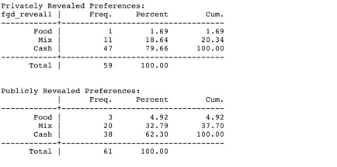
Source: Lentz et al. 2012

Interpreting findings on preferences
Tallying preferences for cash, food or a mixture will reveal whether there is a strongly preferred option or whether there is diversity of preferences among respondents. If there isn’t a dominant preference, try to tease out whether that diversity is due to household characteristics (e.g., household heads prefer cash but non-heads prefer food or a mix) or due to market-based factors (e.g., households lying within a certain radius from a market prefer cash and vouchers while those lying outside the radius do not).

If household characteristics are driving preferences, consider weighing the preferences more heavily for those households are most representative of the population to be targeted. Alternatively, because households have broader basic needs than just food, even very poor households commonly express a clear preference for at least some cash in addition to food. Proportional piling using beans or stones can be an effective way to get at a respondent’s preferred mixture.

If market-based factors are driving the preference differences and if the response analysis points to one form of transfer but households prefer another, investigate this issue further. Households may have additional insight into how markets operate or face constraints that were not well-captured in other aspects of the analysis.

Limitations of the assessing preferences
To most accurately assess preferences, it is important to know who will be the likely recipients. However, targeting decisions may be made later, once budgetary allotments are known. Further, household respondents will need to clearly understanding the choice they are making. Respondents may prefer food over vouchers if vouchers can only be spent at inconveniently located market shops. However, they may prefer vouchers if the vouchers are flexible. Respondents concerned about inflation may be wary of non-inflation indexed cash transfers.

Income and consumption
Preferences shape demand. Whether or not a household is able to consume what they prefer depends not only on market access and food availability but also on income. We consider a few important relationships between the food commodities demanded and income. Engel’s Law states that as income increases, the proportion of the budget spent on food decreases. Bennett’s Law states that as income increases, the proportion of the budget spent on ‘starchy-staples’ decreases. Bennett’s Law reflects a desire for dietary diversity.

The below figure from Timmer et al. (1983) shows typical demand patterns for food as income increases. Engel’s Law is designated by “Food expenditure”; Bennett’s Law is designated by “Starchy staples.” As income increases, the quality of food consumed increases. This pattern suggests that poor households spend a greater proportion of their income on food consumption relative to wealthier households (Engel’s Law) and that they spend more of their incomes on starchy staples (Bennett’s Law). Therefore, price increases of starchy staples are extremely burdensome to poor households because large portions of their budgets are spent on staples.

Measures of Food Consumption Relative to Household Income Level
(in Log form)
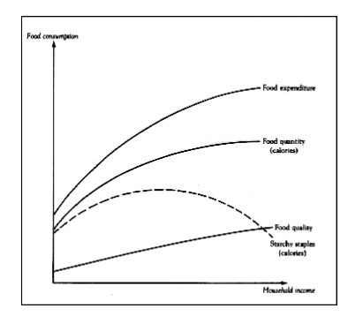
Source: Timmer et al. (1983). p. 57. Note: The figure is drawn in logarithms to illustrate elasticities: (log) Food quality = (log)food expenditure - (log)food quantity.

How much a price increase of a commodity affects consumers depends on whether the commodity has many substitutes. If alternative products are easily available, households may shift their consumption to the substitute, avoiding the burden of the price increase.

Engel’s law also tells us that when incomes increase, demand for food increases. The effect on demand for particular products depends on whether such goods are normal goods or inferior goods. Normal goods are those for which an increase (decrease) in income results in an increase (decrease) in demand. This pattern is because the income and substitution effects are both operating in the same direction, as seen in the figure below. For inferior goods, an increase (decrease) in income results in a decrease (increase) in demand. When incomes fall for very poor households, demand for an inferior good can increase because households can no longer afford to buy more expensive foods and thus spend more money on cheaper, lower quality calorie sources. Potatoes are a common inferior good for many households. For inferior goods, the income effect is in the opposite direction from the substitution effect (i.e., the income and substitution effects are countervailing) resulting in a decrease in demand when income increases.

Income and Substitution Effects due to a Price Increase
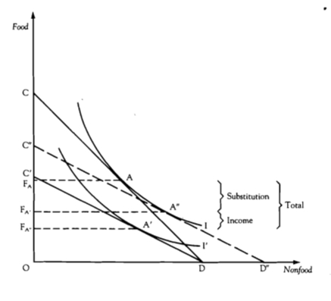
Source: Timmer et al. 1983. P. 44.

One implication of consumption of inferior products is that all else equal, price increases for inferior goods with few substitutes harm consumers’ welfare more than equivalent price increases for substitutable or normal goods.

Income and price elasticities of demand
When households strongly prefer one type of food to another, they will be less willing to substitute a cheaper food when prices of the preferred food rise or when their incomes fall.

A measure of the relationship between changes in income and changes in the quantity demanded is the income elasticity of demand. Transfers increase a household’s income (food is an in-kind form of income). The income elasticity measures the effect of a one percent increase in income on the percent of quantity demanded. An equivalent income increase will generate smaller changes in demand for someone with “less elastic” demand relative to someone with more elastic demand.
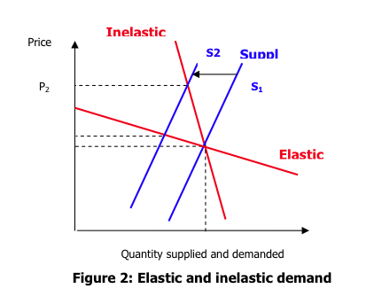
Source: FEWS NET (2008) Market Analysis and Assessment. Lesson 1, p. 24.

The relationship between changes in prices and changes in the quantity demanded is the price elasticity of demand. The price elasticity of demand measures how much quantity changes when the price changes by one percent. The expected increase in demand for a particular commodity can be used to estimate the possible increase in volume demanded due to a transfer. The more vertical a demand curve is (labeled “inelastic”) below, the less responsive demand is to increases in price.

How does the analytic assist in answering the relevant MIFIRA sub-question?

1b: How will local demand respond to transfers?
Using elasticities, we can estimate how much demand could change based on the form of transfer.

Computing elasticities
General elasticity formula:
e ij = (Percentage change in variable i) / (Percentage change in variable j)

Income elasticity formula:
e income = Quantity % change / Income % change = $\frac{\frac{∆x}{x}}{\frac{∆p}{p}} = ∂lnx/∂lnp$
The income elasticity of demand reflects the expected percentage change in demand for a product (in this case, food or a particular food commodity) for a one percent change in household income (e.g., due to an inflow of cash or food). Elasticities are often plotted in log-log form so that the slope of the graph directly reflects the elasticity.

Income elasticities lie between 0 and 1. Larger income elasticities indicate that a one percent increase in income results in larger increase in demand. The closer the income elasticity is to 1, the more elastic (or sensitive to income changes) it is. Therefore, an income elasticity for food of 0.4 indicates that a one percent increase in income increases demand by 0.4 percent, while an income elasticity of 0.8 indicates that the same income increase would increase food demand by 0.8 percent.

Own-price elasticity formula:
e own price = Quantity % change / Price % change

Cross-price elasticity formula:
e cross price = Quantity % change for good 1 / Price % change for good 2

Price elasticities generally lie below 0. The closer a price elasticity is to 0, the more inelastic it is. When a price increase causes quantity to decrease by the same percent, then the elasticity is -1, known as unit elasticity. When elasticities are less than – 1 (i.e., more negative), then the more elastic the price elasticity is, and the larger the decrease in demand due to an increase in price.

The below figure from WFP shows income and price elasticities for the bread and cereals food group by per capita GDP. As expected, when GDP increases, increases in income results in smaller increases in food purchases and the quantities purchased are less responsive to price changes.

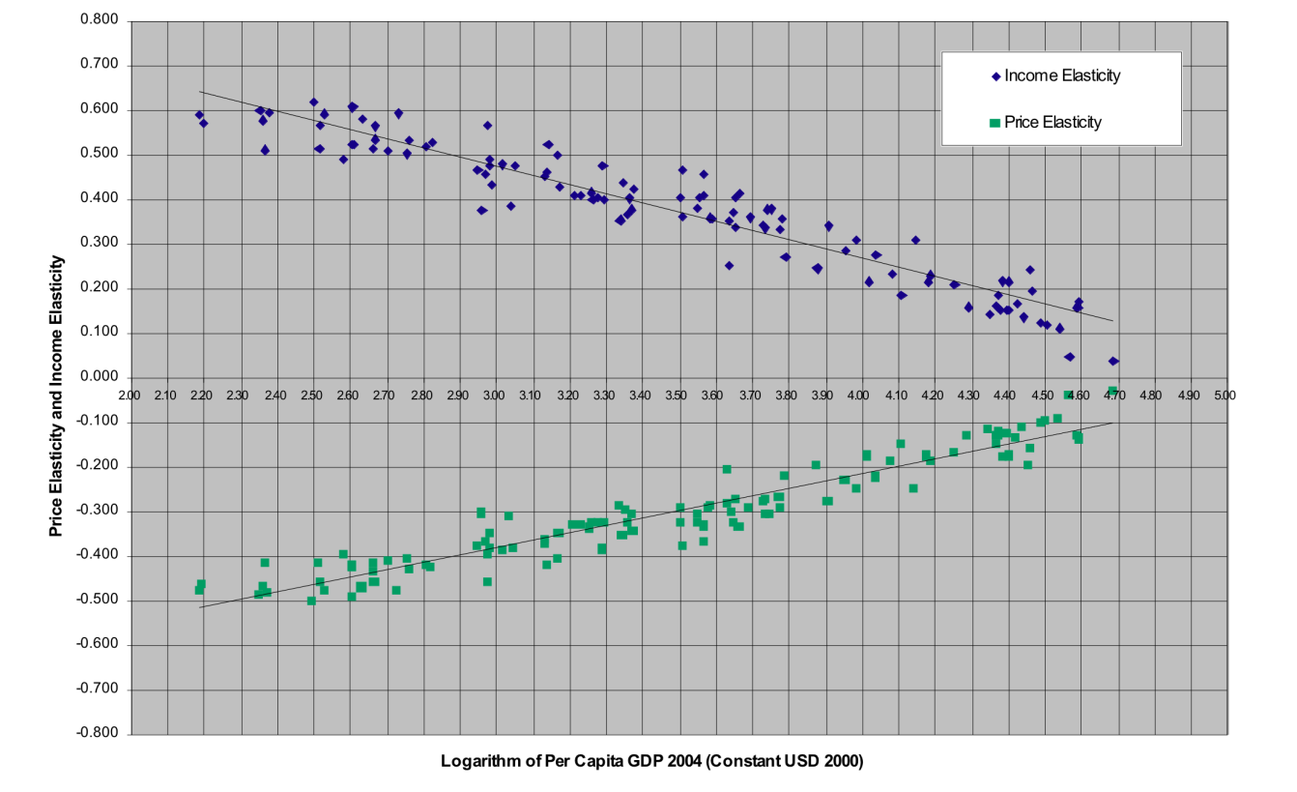
Source: Sited in World Food Programme, (2008) “PDPE Market Analysis Tool: Price and income elasticities” p.6: USDA-ESR elasticities database, 1996, and GDP data from WDI 2006.
Note: Income and price elasticity estimates for the cereal and bread food groups are extracted from the USDA-ESR database collected in 1996. GDP/capita values are in constant 2000 USD for the year 2004. These values were extracted from the WDI 2006 database. The number of countries for which data was available is 107.

The following FEWS NET tables list what can influence the elasticities of demand and supply (2008; Lesson 1, p. 24). Cash transfers stimulate demand more when distributed to poorer people in lean seasons. Transfers in kind (i.e., as food) stimulate food demand more than cash but because of Engel’s Law (i.e., the income elasticity of food is less than one), transfers in kind typically lower market demand. If these induced market demand changes are high, and supply is inelastic, then distribution of cash may harm non-beneficiaries.

Income elasticities can vary from individual to individual. They can also vary by season, by commodity, and by the form of transfer (e.g., vouchers versus cash). Variable elasticities of demand by income means that effective targeting will disrupt local markets less than poor targeting will. If non-poor households receive food, they may sell more of it because they face lower income elasticities of demand than poorer households, potentially further depressing local food prices. As the ratio of food expenditures to income increases, price increases more negatively affect poor non-recipients in local markets and in source LRP markets.

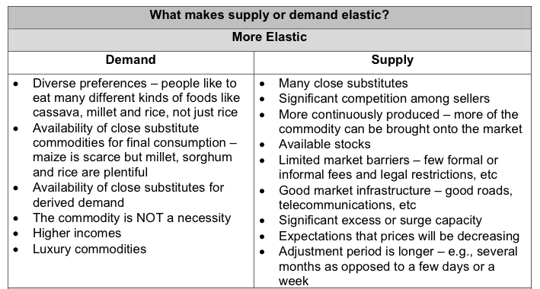
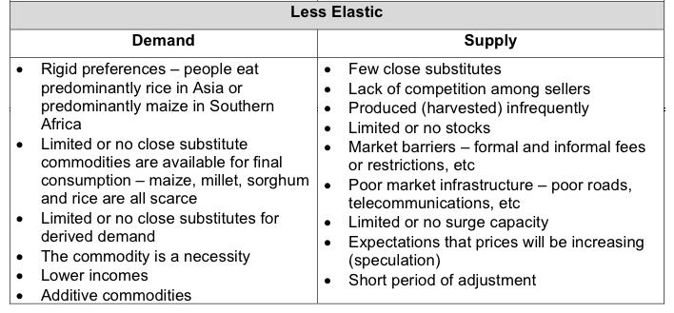
Applying elasticities to estimate changes in demand
Example 1: Income elasticities
In this example, we estimate the increase in demand due to cash transfers. The expected demand expansion due to a transfer equals the product of the income elasticity of demand and the value of the transfer to households.

Once the approximate estimated increase in demand is known, interviews with traders and analysis of market data can help determine whether traders can expand their capacity to meet this increase.

In the example below, we estimate an agency has identified food insecurity in two different marketsheds, A and B. Based on the needs assessment, the agency decides it needs to distribute $100,000 in marketshed A and the remaining $200,000 in marketshed B. The agency is interested in both the total amount of the local staple food that could be purchased with that distribution and the total amount of the local staple that will likely be purchased.

Income Elasticity of Demand: Estimating increase in tons demanded for a major staple food due to cash distribution
 | A | B | C=A/B | D | E | F=C*D | G=C*E
 | Budget for the transfer disbursement (net of distribution costs) | Cost of staple per metric ton | Tons of food that could be purchased with cash | Income elasticity of demand: More elastic | Income elasticity of demand: Less elastic | Additional tons demanded: High estimate | Additional tons demanded: Low estimate
Marketshed A | $100,000 | 1900 | 52.63 | 0.6 | 0.3 | 31.58 | 15.79
Marketshed B | $200,000 | 1900 | 105.26 | 0.6 | 0.3 | 63.16 | 31.58
Source: Mude et al. (forthcoming)

To estimate the induced price effects in a market due to transfers, the analyst should use the aggregate transfers to households in the marketshed area so as to capture the aggregate demand effect.

A similar technique can be applied to estimate the expected price increases in source markets due to local or regional purchases by operational agencies, using the total purchase value instead of aggregate transfer value.

If the expected induced price increases are on the order of 10% or more in a market, the actions (whether LRP or cash transfers to households) are likely to harm food insecure net buyers in those markets and may be inadvisable.

Example 2: Price elasticities
Price elasticities can be used to estimate the effect of increasing prices on consumers’ demand. Also, the effect of increased food supply on prices can be estimated using price elasticities.

Inverse Price Elasticity of Demand: Estimating % Change in Price due to a % Change in Supply
In this example, we estimate the impact on prices of food aid delivered to a market. We consider two scenarios, using the inverses of less elastic and more elastic price elasticities of demand. Less elastic price elasticities of demand are closer to zero and indicate that a small change in prices will not lead to a large change in demand. A low price elasticity of demand is common when there are few substitutable products. The price elasticities are given and the inverses are the reciprocal values. Using the inverse of price elasticity of demand, we estimate the amount prices would have to change for a fixed increase in supply.

Based on a needs assessment, the estimated volume of food aid is 25 metric tons, while the estimated amount of food supplied by the market used by targeted recipients is 500 metric tons (we discuss how to estimate the total volume in the marketshed separately). By multiplying the inverse of the less elastic price elasticity by the percent of supply expansion, we find that prices are expected to fall by 20%. However, in the case of the inverse of the more elastic price elasticity of demand, we find that prices only fall by 6.25% for the same delivery.

Inverse price elasticity * percent change in supply = percent change in price

-4.00*5% = x = -20%

 |  | Less elastic | More elastic
A | Price elasticity of demand | -0.25 | -0.80
B | Inverse price elasticity of demand | -4.00 | -1.25
C | Estimated tons of food aid delivered (i.e., addition to local supply) | 25 | 25
D | Estimated market supply pre-delivery | 500 | 500
E=C/D*100 | % of supply expansion due to food aid deliveries | 5% | 5%
F=B*E | Estimated % change in prices | -20.00% | -6.25%
Source: Mude et al. (forthcoming)

This method is particularly helpful when agencies are considering whether to pursue a local or regional procurement approach. Procuring commodities with inelastic or less elastic price elasticities could lead to greater price increases than procuring commodities with more elastic price elasticities.

Data sources
There are three data sources for elasticity measures.

Household survey data on food consumption and expenditure patterns and prices can be used to compute elasticities. Consumption and expenditure studies may estimate elasticities for particular goods, locations, populations, and seasons. Government statistics bureaus may have estimates from previous household level data collection. Ideally, income elasticity of demand will be differentiated by transfer form, income or wealth class, and season. However, typically, such data will not be available in the relevant period and for the appropriate population.

When appropriate local elasticities are not available, use best guess estimates of the relevant elasticities, drawing on the literature (e.g., Timmer et al. 1983). Income elasticities of demand for staple food commodities typically vary between 0.15 and 0.85 depending on the population, season and commodity, higher for poorer groups and hungry seasons and higher quality foods. Use a higher income elasticity of demand for (a) in-kind transfers (e.g., food aid) than cash transfers, (b) poorer households, and (c) lean, pre-harvest seasons. If elasticities are not available for the country/product in question, use high and low values of the next best available elasticities to compute a band of expected changes. As a starting point, see:
- Food Budget Shares and Demand Elasticities from USDA (1996)
http://www.ers.usda.gov/data/InternationalFoodDemand/
and
http://www.ers.usda.gov/Data/elasticities/query.aspx

As a crude approximation of the income elasticity of demand, use household survey data to compute the ratio of weekly expenditures on food for an average household (including the market value of food produced at home) divided by the weekly earnings for the household (including the value of home-produced goods it consumes). The ratio of food expenditure to earnings also provides an exact short-term approximation of the effect of a price change on household welfare. This is useful if one wants to identify those households most likely to be harmed by any induced price rises.

Marginal propensity to consume
The marginal propensity to consume (MPC) is similar to the income elasticity of demand. While the elasticity measures how a one percent increase in income changes the percent of food purchased, the MPC considers how much of the additional transfer will be spent as food. When reliable estimates of the income elasticity are unavailable, it is possible to generate expected MPCs through focus group discussions or interviews with households.

How does the analytic assist in answering the relevant MIFIRA sub-question?

1b: How will local demand respond to transfers?
We can use the marginal propensity to consume to estimate how local demand will respond to transfers.

How to estimate and use the MPC
The marginal propensity to consume is the ratio of the change in consumption resulting from a change in income (e.g., value of the transfer).

MPC = change in consumption/change in income

To use the MPC requires estimates of the likely size of the transfer (which we treat as income) and the likely increase in consumption.

A simple way of computing the MPC is to ask likely recipient households, either during a survey or in a focus group discussion, how they would spend a one-time gift. Using proportional piling, households indicate what proportion of this gift would be spent on food. The denominator is the size of the one-time gift, while the numerator is the value of the gift that would be spent on food.

Aggregating across households, it is possible to assess how much additional food traders would likely need to bring into the community following a cash transfer. In the example below, we chose the value of the gift to be roughly equivalent to the value of a distribution of food.

MARGINAL INCOME

- If you received a gift of 2000 Ksh today, what are the ways in which you would use this money? And how would you distribute the Ksh 2000 across these ways?

Ways of using the money  Use code below | Distribution of the total  Ksh 2000

Code
1: Food  2: School fees  3: Healthcare or medicine for family  4: Clothing | 5: Animal healthcare  6: Repay loan  7: Savings  8: Gift with no expectation of repayment | 9: Loan with expectation of repayment  10: Investment  11: Livestock  12: Celebration  13: Other _______________

A complementary approach to the above question is to use proportional bean piling exercises to obtain an estimate of relative proportions – for example, by ensuring that recipients allocate the entire value of the gift across different piles. Bean piling exercises can also be useful in understanding recipients’ own preferences regarding the proportion of cash and in-kind assistance desired, useful information for answering question 1e.

Limitations of MPCs
One-time transfers may be spent differently than regularly re-occurring transfers. Therefore, MPCs provide a rough approximation of increases in demand.

Example of applying the MPC in northern Kenya
In northern Kenya, we estimated household marginal propensity to consume food (MPCF) from an incremental change in income in order to approximate the amount of cash transfer that a recipient household will use to purchase food (Mude, Ouma, and Lentz forthcoming). To compute the MPCF, we asked each household how they would spend a one-time gift of Ksh2000 across several categories and computed the fraction to be spent on food. Households indicate that they are likely to spend between 42% and 53% of the gift on food. In other words, these households are likely to spend almost half of any one-time cash transfer they receive on food. Given that a one-time gift could be spent differently than a regularly occurring transfer during food insecurity, we use our elicited MPCF as a lower bound to demand response for food and an MPCF of 75% as an upper bound for demand response for food.

Terms of trade
The terms of trade (ToT) is a ratio of two prices. Usually, the numerator is the source of income, and the denominator is the price of the food staple. The choice of which two prices to use as a ToT ratio will depend on the local livelihood and consumption patterns. For example, a common ToT in pastoral areas is the ratio of livestock price over the price of the main cereal purchased for consumption. Other common ToTs use wage labor in the numerator.

How does ToT assist in answering the relevant MIFIRA sub-question?
1b: How will local demand respond to transfers?
Changes in the ToT indicate that households may no longer be able to purchase same basket of goods. This ratio allows us to examine household purchasing power. The ToT can be an important source of early warning and monitoring information, especially when compiled over time so that changes can be identified.

How to estimate and use terms of trade
In ToTs, the main livelihood measure is in the numerator while the main staple commodity purchased is in the denominator (WFP 2008. “PDPE Market Analysis Tool: Terms of Trade” p. 6):

Terms of trade for good i and j
TOTij = (Price of good i)/(Price of good j)

Be sure to use the same currency and physical units (e.g., local currency and metric tons).

As the ToT declines, the livelihood price is decreasing relative to the staple price, potentially indicating decreased ability to purchase the staple commodity.

Sources of information on numerators include income studies and key informant interviews. Ask what is/are the main cash income sources of these groups, such as the sale of a cash crop, livestock or daily labour? Sources of information on denominators include consumption and expenditure studies and key informant interviews. Ask what is/are the main staple foods consumed by these groups? Secondary sources may have collected this information. Crop and livestock prices may be available from the FAO, ministry of agriculture, and WFP while wages may be available from the ministry of labor and bureau of statistics.
When compiling ToTs, focus on the income sources and food consumption of the target groups or livelihood groups of interest. In communities with diverse income sources or staple foods, compiling and monitoring a few ToTs may be more informative than focusing on just one ratio.

Limitations of the ToT
The ToT does not reflect the possible mitigating effects of households switching to substitutes and can therefore be misleading. In cases where households consume a wide variety of staples, or substitute freely across staples, price increases in the denominator are not necessarily indicative of worsening food insecurity. Similarly, price changes in the numerator may be less informative for communities with diverse sources of income.

ToTs using different numerators or denominators are not comparable.

The ToT also does not identify the market whose price changes are driving the ToT change (i.e., is the numerator, denominator, or both changing?). Therefore, when graphing or describing the ToT, also include the underlying prices series.

Example of cashew-to-rice ToT in Guinea Bissau
WFP’s cashew-to-rice terms of trade example from Guinea Bissau shows how decreases in the price of cashews, a main cash crop, compared to both domestic and international rice prices and indicated worsening food security for cashew growers.

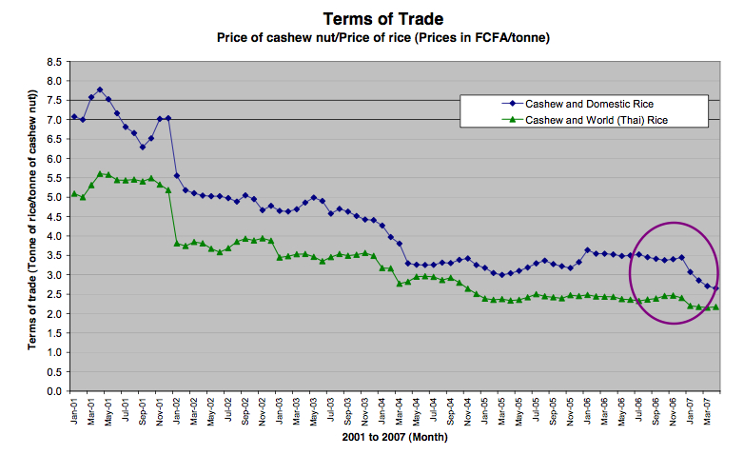
Source: WFP 2008. “PDPE Market Analysis Tool: Terms of Trade” p. 6

Commodities to examine
Needs assessment and key informant discussions should provide information on key commodities consumed by food insecure or at-risk households. Nutritional assessments may identify other needs, for example for foods rich in iron to fight anemia. After examining basic consumption patterns, the analyst should be able to identify which commodities to focus on for further price information. These commodities should be the ones that households purchase for consumption during hungry periods.

An initial list of commodities should include foods that meet the following criteria:

Choose commodities that are crucial for food security, such as staples. Also consider including major sources of fat and protein, especially if large portions of food budgets are spent on these items. Consider including other foods containing key micronutrients (e.g., iron), especially if these micronutrients are missing or under-consumed in diets. A nutritional assessment may find that particular products are highly important for diets, such as fresh fruit and vegetables in refugee and IDP camps.

Choose commodities consumed by the target population, and assess whether seasonal consumption patterns differ and include products relevant for hungry-season consumption. Choose commodities that are generally available on the market. For example, corn-soy blend (CSB) is rarely available in large quantity on local markets and therefore would not be a good candidate.

Narrow the list of candidate commodities
Winnow down the number of commodities to the smallest number possible. We are most concerned about commodities whose price changes are most likely to most impact the poor. Therefore, focus particularly on staples and substitutes, but also key complementary goods and services, such as water, medicine, fuel, or shelter.

To narrow the list of commodities, compute budget shares. A budget share is the ratio of the amount spent on one commodity for a given time-period divided by the amount of (cash and non-cash) budget earned for the same time period. Compute budget shares for the same 2-4 commodities most heavily purchased for several different socio-economic groups. Select those commodities’ whose price changes (i.e., those commodities with a large budget share) most hurt the intended targeted recipients. Identify the substitutes for the prospective commodity candidates and whether they are inferior or normal goods. When commodities have many substitutes, consider examining some of those substitutes. If the price of a commodity rises, and households can substitute away from it, they will be less harmed by the price increase. Similarly, price increases for inferior goods will disproportionately harm poor households. Therefore, when inferior goods are consumed, tracking them can be more informative about than tracking normal goods.

A final reason to limit the number of commodities examined is that traders are commonly extremely busy and rarely have time to spend multiple hours answering a survey. In order to avoid respondent fatigue, ask each trader about no more than two or three commodities and limit the survey to a maximum of one and a half hours (Certain commodities may have more complex supply and marketing chains (e.g., those imported through long channels versus those produced and sold locally) than others and therefore responses about some commodities may require more time than others.). If supply chains are the same for several products (e.g., millet and sorghum), when analyzing certain market aspects (e.g., competition), rely on only one representative product from those chains.

The number of commodities to consider will depend on: local consumption patterns, nutritional concerns, commodity characteristics (e.g., substitutability, dominance in diet), timeliness, and cost. Each additional commodity increases the time per survey and the number of traders to interview.

Example of commodity choices
Initial findings indicate that cash and vouchers, relative to food aid baskets increase dietary diversity (Dunn, S. 2009. “External Evaluation: Fresh Food Voucher by Action Against Hunger in Dadaab Refugee Camps, Kenya”). Dietary diversity may be a programming objective and this may drive the types of commodities to examine. In Dadaab refugee camps, a small vouchers program allowed targeted households to supplement their food aid rations with fresh fruit and vegetables, milk and eggs. These particular products were chosen for vouchers based on market availability, micronutrient composition and micronutrient requirements, and cost.

Final Remarks
Data requirements and the representativeness of secondary sources will drive tradeoffs across these measures. If representative of the consumption patterns of the target population, income elasticities of demand are generally preferable to marginal propensities to consume. However, if only broad elasticities are available, collecting MPC data and computing demand responses with both MPCs and elasticities can provide a range of increases in demand. Then, analysts can verify whether supply appears able to respond to the entire range of increased demand. Scenario building using elasticities and MPCs will be discussed further in “Putting together the pieces.”
Computing terms of trade is most useful in communities with relatively low substitutability across commodities and livelihoods. Tracking ToT changes is a relatively simple monitoring and evaluation tool. Large decreases in ToT indicate that households may be facing worsening food insecurity.

